AI – 1.1 BFS Undirected Graph

Code

# BFS algorithm in Python

import collections

# BFS algorithm

def bfs(graph, root):

    visited, queue = set(), collections.deque([root])

    visited.add(root)

    while queue:

        # Dequeue a vertex from queue

        vertex = queue.popleft()

        print(str(vertex) + " ", end="")

        # If not visited, mark it as visited, and

        # enqueue it

        for neighbour in graph[vertex]:

            if neighbour not in visited:

                visited.add(neighbour)

                queue.append(neighbour)

if __name__ == '__main__':

    graph = {0: [1, 2], 1: [2], 2: [3], 3: [1, 2]}

    print("Following is Breadth First Traversal: ")

    bfs(graph, 0)

Output

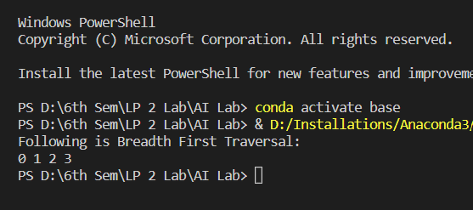

AI- 1.2 DFS Undirected Graph

Code

# DFS algorithm in Python

# DFS algorithm

def dfs(graph, start, visited=None):

if visited is None:

visited = set()

visited.add(start)

print(start)

for next in graph[start] - visited:

dfs(graph, next, visited)

return visited

graph = {'0': set(['1', '2']),

'1': set(['0', '3', '4']),

'2': set(['0']),

'3': set(['1']),

'4': set(['2', '3'])}

dfs(graph, '0')

Output

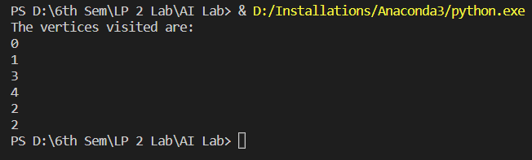

AI- 2 A Star algorithm

Code

from collections import deque

class Graph:

    # example of adjacency list (or rather map)

    def __init__(self, adjacency_list):

        self.adjacency_list = adjacency_list

    def get_neighbors(self, v):

        return self.adjacency_list[v]

    # heuristic function with equal values for all nodes

    def h(self, n):

        H = {

            'A': 1,

            'B': 1,

            'C': 1,

            'D': 1

        }

        return H[n]

    def a_star_algorithm(self, start_node, stop_node):

 # open_list is a list of nodes which have been visited, but who's neighbors haven't all been inspected, starts off with the start node

# closed_list is a list of nodes which have been visited and who's neighbors have been inspected

        open_list = set([start_node])

        closed_list = set([])

  # g contains current distances from start_node to all other nodes the default value (if it's not found in the map) is +infinity

        g = {}

        g[start_node] = 0

        # parents contains an adjacency map of all nodes

        parents = {}

        parents[start_node] = start_node

        while len(open_list) > 0:

            n = None

   # find a node with the lowest value of f() - evaluation function

            for v in open_list:

                if n == None or g[v] + self.h(v) < g[n] + self.h(n):

                    n = v;

            if n == None:

                print('Path does not exist!')

                return None

  # if the current node is the stop_node

  # then we begin reconstructin the path from it to the start_node

            if n == stop_node:

                reconst_path = []

                while parents[n] != n:

                    reconst_path.append(n)

                    n = parents[n]

                reconst_path.append(start_node)

                reconst_path.reverse()

                print('Path found: {}'.format(reconst_path))

                return reconst_path

            # for all neighbors of the current node do

            for (m, weight) in self.get_neighbors(n):

     # if the current node isn't in both open_list and closed_list

# add it to open_list and note n as it's parentif m not in open_list and m not in closed_list:

                    open_list.add(m)

                    parents[m] = n

                    g[m] = g[n] + weight

                # otherwise, check if it's quicker to first visit n, then m and if it is, update parent data and g data and if the node was in the closed_list, move it to open_list

                else:

                    if g[m] > g[n] + weight:

                        g[m] = g[n] + weight

                        parents[m] = n

                        if m in closed_list:

                            closed_list.remove(m)

                            open_list.add(m)

            # remove n from the open_list, and add it to closed_list because all of his neighbors were inspected

            open_list.remove(n)

            closed_list.add(n)

        print('Path does not exist!')

        return None

adjacency_list = {

'A': [('B', 1), ('C', 3), ('D', 7)],

'B': [('D', 5)],

'C': [('D', 12)]

}

graph1 = Graph(adjacency_list)

graph1.a_star_algorithm('A','D')

Output

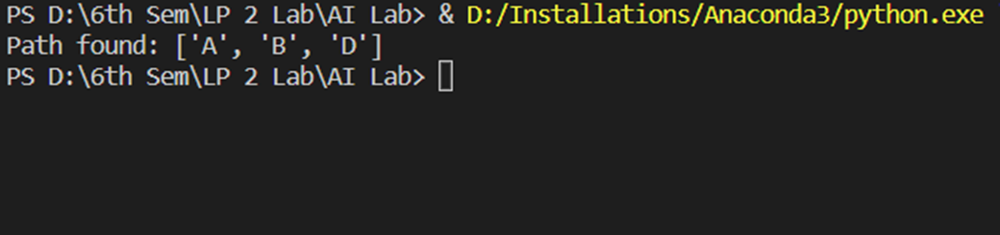

AI- 3 Greedy Search Algorithm- Job Scheduling Problem

Code

# Program to find the maximum profit

# job sequence from a given array

# of jobs with deadlines and profit

# function to schedule the jobs take 2

# arguments array and no of jobs to schedule

def printJobScheduling(arr, t):

# length of array

n = len(arr)

# Sort all jobs according to

# decreasing order of profit

for i in range(n):

for j in range(n - 1 - i):

if arr[j][2] < arr[j + 1][2]:

arr[j], arr[j + 1] = arr[j + 1], arr[j]

# To keep track of free time slots

result = [False] * t

# To store result (Sequence of jobs)

job = ['-1'] * t

# Iterate through all given jobs

for i in range(len(arr)):

# Find a free slot for this job

# (Note that we start from the

# last possible slot)

for j in range(min(t - 1, arr[i][1] - 1), -1, -1):

# Free slot found

if result[j] is False:

result[j] = True

job[j] = arr[i][0]

break

# print the sequence

print(job)

# Driver COde

arr = [['a', 2, 100], # Job Array

['b', 1, 19],

['c', 2, 27],

['d', 1, 25],

['e', 3, 15]]

print("Following is maximum profit sequence of jobs")

# Function Call

printJobScheduling(arr, 3)

Output

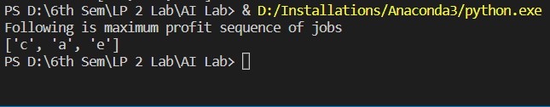

AI- 4. N-queens problem

Code

import io

import random

import string

import warnings

import numpy as np

from sklearn.feature_extraction.text import TfidfVectorizer

from sklearn.metrics.pairwise import cosine_similarity

import warnings

warnings.filterwarnings('ignore')

import nltk

from nltk.stem import WordNetLemmatizer

# nltk.download('popular', quiet=True)

# nltk.download('punkt')

# nltk.download('wordnet')

with open('chatbot.txt','r', encoding='utf8', errors ='ignore') as fin:

    raw = fin.read().lower()

#Tokenisation

sent_tokens = nltk.sent_tokenize(raw)

word_tokens = nltk.word_tokenize(raw)

# Preprocessing

lemmer = WordNetLemmatizer()

def LemTokens(tokens):

    return [lemmer.lemmatize(token) for token in tokens]

remove_punct_dict = dict((ord(punct), None) for punct in string.punctuation)

def LemNormalize(text):

    return LemTokens(nltk.word_tokenize(text.lower().translate(remove_punct_dict)))

# Keyword Matching

GREETING_INPUTS = ("hello", "hi", "greetings", "sup", "what's up","hey","Helo")

GREETING_RESPONSES = ["hi", "hey", "hi there", "hello", "I am glad! You are talking to me"]

def greeting(sentence):

    for word in sentence.split():

        if word.lower() in GREETING_INPUTS:

            return random.choice(GREETING_RESPONSES)

def response(user_response):

    robo_response=''

    sent_tokens.append(user_response)

    TfidfVec = TfidfVectorizer(tokenizer=LemNormalize, stop_words='english')

    tfidf = TfidfVec.fit_transform(sent_tokens)

    vals = cosine_similarity(tfidf[-1], tfidf)

    idx=vals.argsort()[0][-2]

    flat = vals.flatten()

    flat.sort()

    req_tfidf = flat[-2]

    if(req_tfidf==0):

        robo_response=robo_response+"I am sorry! I don't understand you"

        return robo_response

    else:

        robo_response = robo_response+sent_tokens[idx]

        return robo_response

flag=True

print("ROBO: My name is Robo. I will answer your queries about Investments. If you want to exit, type Bye!")

while(flag==True):

    user_response = input()

    user_response=user_response.lower()

    if(user_response!='bye'):

        if(user_response=='thanks' or user_response=='thank you' ):

            flag=False

            print("ROBO: You are welcome..")

        else:

            if(greeting(user_response)!=None):

                print("ROBO: "+greeting(user_response))

            else:

                print("ROBO: ",end="")

                res = response(user_response)

                nlines = res.count('\n')

                if nlines > 0:

                    res = res.split("\n",1)[1]

                print(res)

                sent_tokens.remove(user_response)

    else:

        flag=False

        print("ROBO: Bye! take care..")

Output

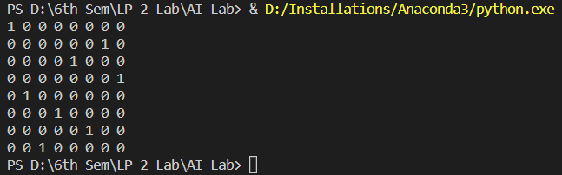

AI-5 Chatbot Application in Python

Code

import io

import random

import string

import warnings

import numpy as np

from sklearn.feature_extraction.text import TfidfVectorizer

from sklearn.metrics.pairwise import cosine_similarity

import warnings

warnings.filterwarnings('ignore')

import nltk

from nltk.stem import WordNetLemmatizer

# nltk.download('popular', quiet=True)

# nltk.download('punkt')

# nltk.download('wordnet')

with open('chatbot.txt','r', encoding='utf8', errors ='ignore') as fin:

    raw = fin.read().lower()

#Tokenisation

sent_tokens = nltk.sent_tokenize(raw)

word_tokens = nltk.word_tokenize(raw)

# Preprocessing

lemmer = WordNetLemmatizer()

def LemTokens(tokens):

    return [lemmer.lemmatize(token) for token in tokens]

remove_punct_dict = dict((ord(punct), None) for punct in string.punctuation)

def LemNormalize(text):

    return LemTokens(nltk.word_tokenize(text.lower().translate(remove_punct_dict)))

# Keyword Matching

GREETING_INPUTS = ("hello", "hi", "greetings", "sup", "what's up","hey","Helo")

GREETING_RESPONSES = ["hi", "hey", "hi there", "hello", "I am glad! You are talking to me"]

def greeting(sentence):

    for word in sentence.split():

        if word.lower() in GREETING_INPUTS:

            return random.choice(GREETING_RESPONSES)

def response(user_response):

    robo_response=''

    sent_tokens.append(user_response)

    TfidfVec = TfidfVectorizer(tokenizer=LemNormalize, stop_words='english')

    tfidf = TfidfVec.fit_transform(sent_tokens)

    vals = cosine_similarity(tfidf[-1], tfidf)

    idx=vals.argsort()[0][-2]

    flat = vals.flatten()

    flat.sort()

    req_tfidf = flat[-2]

    if(req_tfidf==0):

        robo_response=robo_response+"I am sorry! I don't understand you"

        return robo_response

    else:

        robo_response = robo_response+sent_tokens[idx]

        return robo_response

flag=True

print("ROBO: My name is Robo. I will answer your queries about Investments. If you want to exit, type Bye!")

while(flag==True):

    user_response = input()

    user_response=user_response.lower()

    if(user_response!='bye'):

        if(user_response=='thanks' or user_response=='thank you' ):

            flag=False

            print("ROBO: You are welcome..")

        else:

            if(greeting(user_response)!=None):

                print("ROBO: "+greeting(user_response))

            else:

                print("ROBO: ",end="")

                res = response(user_response)

                nlines = res.count('\n')

                if nlines > 0:

                    res = res.split("\n",1)[1]

                print(res)

                sent_tokens.remove(user_response)

    else:

        flag=False

        print("ROBO: Bye! take care..")

Output

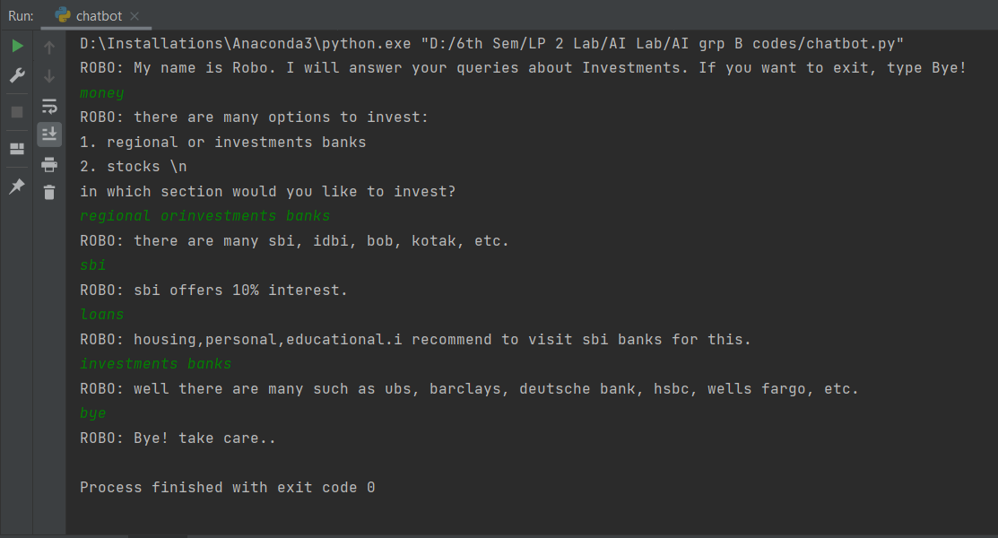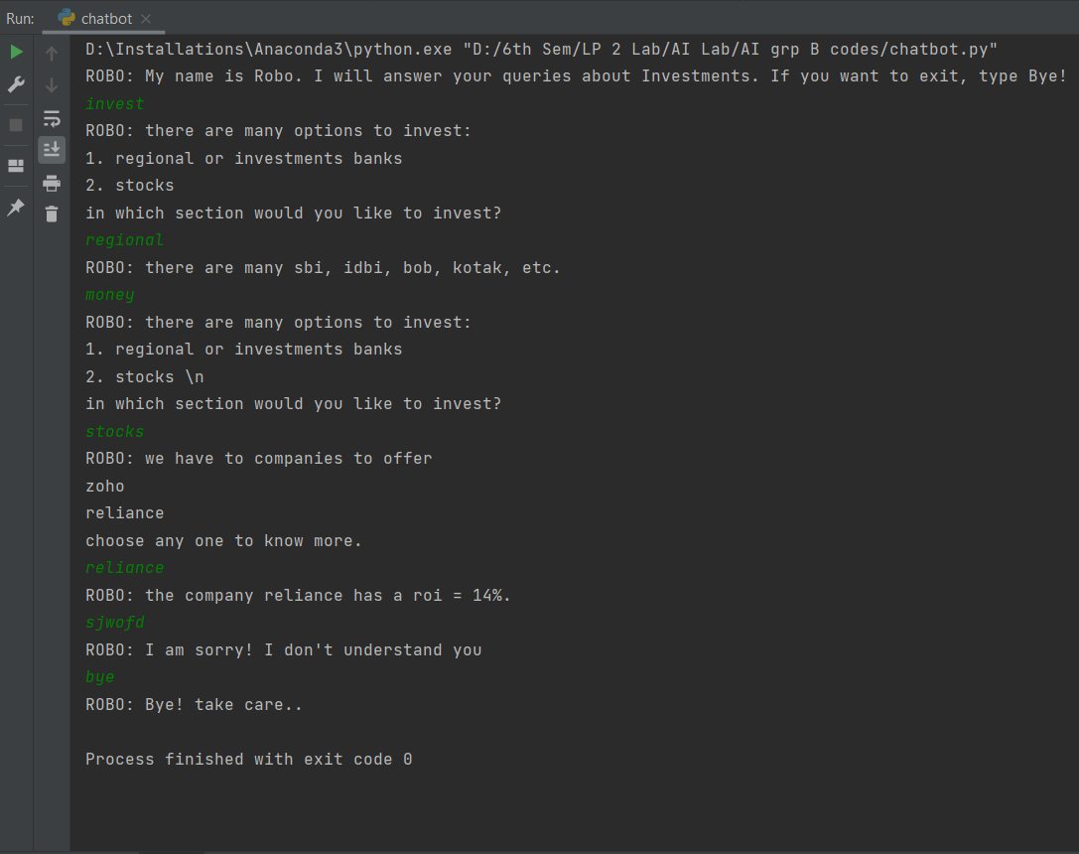

AI-6 Medical Diagnosis Facility Expert System

Code

%To Start the system type start.

% Name : - Chamara M. Dodandeniya

:- use_module(library(jpl)).

start :-sleep(0.4),

        write('-----------------------------------------------------------------'),nl,

        sleep(0.4),

        write('*****************************************************************'),nl,

        sleep(0.2),

        write("###################||| EXPERT SYSTEM |||#########################"),nl,

        sleep(0.4),

        write('*****************************************************************'),nl,

        sleep(0.4),

        write('-----------------------------------------------------------------'),nl,nl,nl,

        /*write("Hi. How are you? First of all tell me your name Please : "),

        read(Patient),*/

        interface2.

       /* hypothesis(Patient,Disease),

        write(Patient),write(', you '), write(' probably have '),write(Disease),write('.'),undo,

        nl,nl,nl,

        sleep(0.7),

        write('*****************************************************************'),nl,

        sleep(0.4),

        write("################||| THANK YOU FOR USE ME |||#####################"),nl,

        sleep(0.4),

        write('*****************************************************************'),nl.*/

    symptom(Patient,fever) :- verify(Patient," have a fever (y/n) ?").

    symptom(Patient,rash) :- verify(Patient," have a rash (y/n) ?").

    symptom(Patient,headache) :- verify(Patient," have a headache (y/n) ?").

    symptom(Patient,runny_nose) :- verify(Patient," have a runny_nose (y/n) ?").

    symptom(Patient,conjunctivitis) :- verify(Patient," have a conjunctivitis (y/n) ?").

    symptom(Patient,cough) :- verify(Patient," have a cough (y/n) ?").

    symptom(Patient,body_ache) :- verify(Patient," have a body_ache (y/n) ?").

    symptom(Patient,chills) :- verify(Patient," have a chills (y/n) ?").

    symptom(Patient,sore_throat) :- verify(Patient," have a sore_throat (y/n) ?").

    symptom(Patient,sneezing) :- verify(Patient," have a sneezing (y/n) ?").

    symptom(Patient,swollen_glands) :- verify(Patient," have a swollen_glands (y/n) ?").

    /*symptom(_,"Sorry, I don't seem to be able to diagnose the disease.").*/

    hypothesis(Patient,measles) :-

        symptom(Patient,fever),

        symptom(Patient,cough),

        symptom(Patient,conjunctivitis),

        symptom(Patient,runny_nose),

        symptom(Patient,rash).

    hypothesis(Patient,german_measles) :-

        symptom(Patient,fever),

        symptom(Patient,headache),

        symptom(Patient,runny_nose),

        symptom(Patient,rash).

    hypothesis(Patient,flu) :-

        symptom(Patient,fever),

        symptom(Patient,headache),

        symptom(Patient,body_ache),

        symptom(Patient,conjunctivitis),

        symptom(Patient,chills),

        symptom(Patient,sore_throat),

        symptom(Patient,runny_nose),

        symptom(Patient,cough).

    hypothesis(Patient,common_cold) :-

        symptom(Patient,headache),

        symptom(Patient,sneezing),

        symptom(Patient,sore_throat),

        symptom(Patient,runny_nose),

        symptom(Patient,chills).

    hypothesis(Patient,mumps) :-

        symptom(Patient,fever),

        symptom(Patient,swollen_glands).

    hypothesis(Patient,chicken_pox) :-

        symptom(Patient,fever),

        symptom(Patient,chills),

        symptom(Patient,body_ache),

        symptom(Patient,rash).

    hypothesis(Patient,measles) :-

        symptom(Patient,cough),

        symptom(Patient,sneezing),

        symptom(Patient,runny_nose).

    hypothesis(_,"disease. But I'm Sorry, I don't seem to be able to diagnose the disease").

    response(Reply) :-

        read(Reply),

        write(Reply),nl.

ask(Patient,Question) :-

    write(Patient),write(', do you'),write(Question),

    /*read(N),

    ( (N == yes ; N == y)

      ->

       assert(yes(Question)) ;

       assert(no(Question)), fail),*/

    interface(', do you',Patient,Question),

    write('Loading.'),nl,

    sleep(1),

    write('Loading..'),nl,

    sleep(1),

    write('Loading...'),nl,

    sleep(1),

    nl.

:- dynamic yes/1,no/1.

verify(P,S) :-

   (yes(S)

    ->

    true ;

    (no(S)

     ->

     fail ;

     ask(P,S))).

undo :- retract(yes(_)),fail.

undo :- retract(no(_)),fail.

undo.

pt(Patient):-

        hypothesis(Patient,Disease),

        interface3(Patient,', you probably have ',Disease,'.'),

        write(Patient),write(', you probably have '),write(Disease),write('.'),undo,end.

end :-

        nl,nl,nl,

        sleep(0.7),

        write('*****************************************************************'),nl,

        sleep(0.4),

        write("################||| THANK YOU FOR USE ME |||#####################"),nl,

        sleep(0.4),

        write('*****************************************************************'),nl.

interface(X,Y,Z) :-

    atom_concat(Y,X, FAtom),

    atom_concat(FAtom,Z,FinalAtom),

    jpl_new('javax.swing.JFrame', ['Expert System'], F),

    jpl_new('javax.swing.JLabel',['--- MEDICAL EXPERT SYSTEM ---'],LBL),

    jpl_new('javax.swing.JPanel',[],Pan),

    jpl_call(Pan,add,[LBL],_),

    jpl_call(F,add,[Pan],_),

    jpl_call(F, setLocation, [400,300], _),

    jpl_call(F, setSize, [400,300], _),

    jpl_call(F, setVisible, [@(true)], _),

    jpl_call(F, toFront, [], _),

    jpl_call('javax.swing.JOptionPane', showInputDialog, [F,FinalAtom], N),

    jpl_call(F, dispose, [], _),

    write(N),nl,

    ( (N == yes ; N == y)

      ->

       assert(yes(Z)) ;

       assert(no(Z)), fail).

interface2 :-

    jpl_new('javax.swing.JFrame', ['Expert System'], F),

    jpl_new('javax.swing.JLabel',['--- MEDICAL EXPERT SYSTEM ---'],LBL),

    jpl_new('javax.swing.JPanel',[],Pan),

    jpl_call(Pan,add,[LBL],_),

    jpl_call(F,add,[Pan],_),

    jpl_call(F, setLocation, [400,300], _),

    jpl_call(F, setSize, [400,300], _),

    jpl_call(F, setVisible, [@(true)], _),

    jpl_call(F, toFront, [], _),

    jpl_call('javax.swing.JOptionPane', showInputDialog, [F,'Hi. How are you? First of all tell me your name please'], N),

    jpl_call(F, dispose, [], _),

    /*write(N),nl,*/

    (   N == @(null)

        ->  write('you cancelled'),interface3('you cancelled. ','Thank you ','for use ','me.'),end,fail

        ;   write("Hi. How are you? First of all tell me your name please : "),write(N),nl,pt(N)

    ).

interface3(P,W1,D,W2) :-

    atom_concat(P,W1, A),

    atom_concat(A,D,B),

    atom_concat(B,W2,W3),

    jpl_new('javax.swing.JFrame', ['Expert System'], F),

    jpl_new('javax.swing.JLabel',['--- MEDICAL EXPERT SYSTEM ---'],LBL),

    jpl_new('javax.swing.JPanel',[],Pan),

    jpl_call(Pan,add,[LBL],_),

    jpl_call(F,add,[Pan],_),

    jpl_call(F, setLocation, [400,300], _),

    jpl_call(F, setSize, [400,300], _),

    jpl_call(F, setVisible, [@(true)], _),

    jpl_call(F, toFront, [], _),

    jpl_call('javax.swing.JOptionPane', showMessageDialog, [F,W3], N),

    jpl_call(F, dispose, [], _),

    /*write(N),nl,*/

    (   N == @(void)

        ->  write('')

        ;   write("")

    ).

help :- write("To start the expert system please type 'start.' and press Enter key").

Output

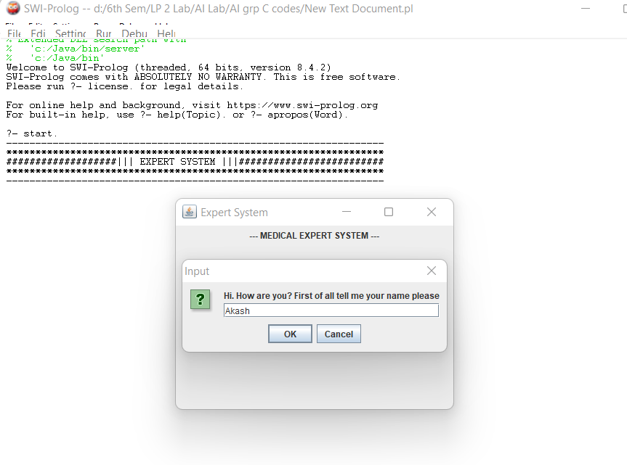

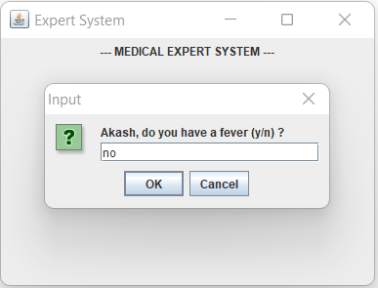

Successfully Diagnosis:

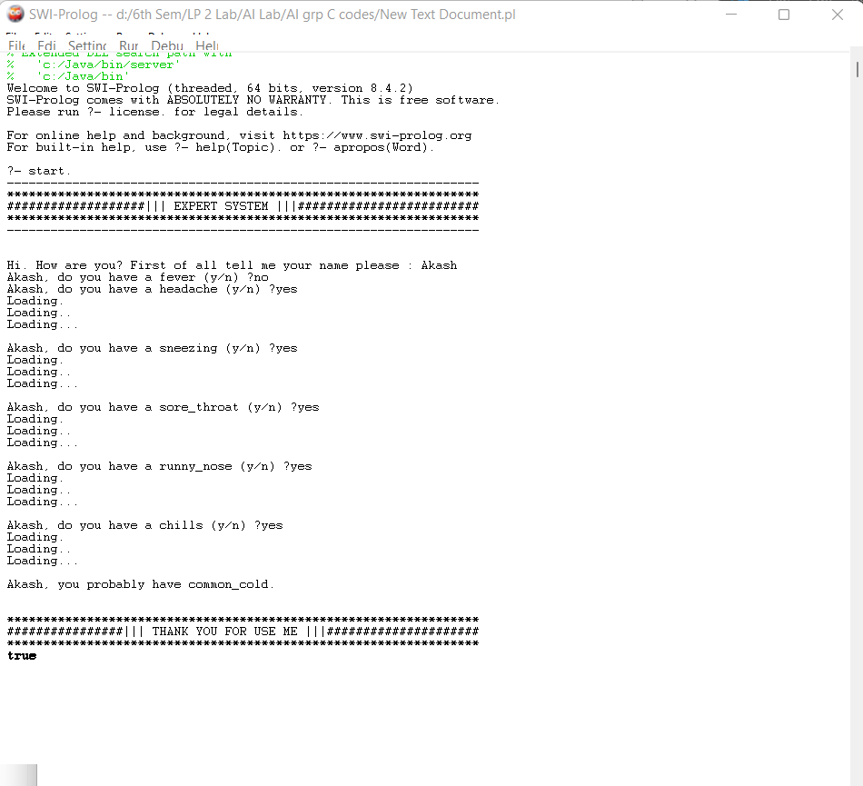

Unsuccessful/Exceptional Diagnosis:

